Book Review

Diarmaid MacCulloch: Lower than the Angels; A History of Sex and Christianity (London, Allen Lane, 2024).

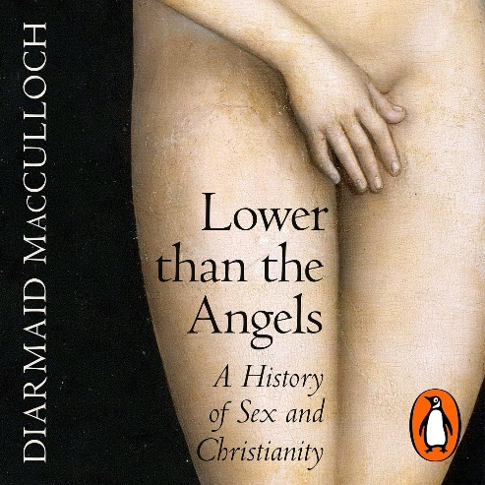

Reviewed by: Hugh Bryant, MA, MRAeS, Dip.Theol.
(Reader in the Church in Wales). Hugh is a graduate of Oriel College, Oxford, where he studied Greats. He went on to become a solicitor specialising in Maritime Law.

This is an important and serious book. One might be tempted to liken it to a history or a museum which concentrates on a particular topic but ends up reflecting the wider history of society as a whole, seen through the prism of its view on the topic in which it specialises. For example, the Mercedes-Benz Museum in Stuttgart is one of the best social history museums. It traces the social history of northern Europe since the 1880s, all seen through the prism of the history of the motorcar.

In the same way, Professor Sir Diarmaid MacCulloch traces the history and evolving theology of Christianity through the prism of its attitude to and practice of sex. It might have introduced a note of frivolity, or at least a contrived viewpoint, but if one reflects on the importance of the chosen prism, it is of the highest importance, albeit with joyful accents.

If man is made in the image of God, but God has no means of procreation, God's image will die out in a couple of generations. That matters. How we procreate, whom we procreate with, under what circumstances and subject to what rules, are all considerations of existential importance for the human race. The fact that there is also pleasure without procreation in relations between the sexes does not detract.

This large and wonderfully researched book goes through all those views, eras and collective understandings of sex which have affected Christianity since the time of the gospels, if not before – Saint Paul’s first and second letters to the Thessalonians are reckoned to be earliest, perhaps no more than 20 years after Jesus’ time on earth.

Nevertheless, one might say that this is all of merely historical importance and has no bearing on current affairs. Au contraire! In the churches of England and Wales, if no others, sex is still causing an enormous amount of difficulty and is highly topical. Sex is a live issue, within the C in W and the C of E. It is good to have a historical perspective.

Outside the church, people complain that the church is either preoccupied with sex to the exclusion of social and moral concerns, or that it promulgates standards of sexual behaviour which are wholly unrealistic in today's society. There are sexual issues involving men, women and those who ‘gender’ themselves as women and men, mutatis mutandis.

Against this background, MacCulloch is dauntless and fearless. He gives you what he believes to be the truth without in any way deferring to conventional or authorised views. This makes the book not only important and serious, but delightful to read.

I started putting Post-it notes wherever I found something noteworthy or an articulation of reality which was new to me. I flagged over 20 such purple passages! This is not to say that one should avoid this book on the grounds that it is too way-out to be sensible.

My feeling is that it is entirely the other way round, and that this is a book which everyone at the top of the churches needs to have read, and everyone in the pews will gain great wisdom and insight from learning the history of various evolving treatments of sexual issues and the place of women in society and the churches.

That having been said, MacCulloch seems to have a deliciously schoolboy view on matters sexual. There are no actual ‘knob jokes’ in this erudite tome; but I get the distinct impression that in many instances Professor MacCulloch is looking quizzically on, with one eyebrow raised, ready to smile at something scatological or bizarre. It is a happy blend of a schoolboy sense of humour and a mature, wise historian who has expertly marshalled all this raw and exciting material.

Some instances: in chapter 2, looking at the time before Jesus from 1500–300 BCE, ‘Most significantly, for centuries the God of Israel enjoyed a wife, Asherah, a fruitful deity who had long been paired with leading west Asian male gods’ (p.35) - and see what happened to her at p.40. Who knew? God was married.

Or as Christians in the first three centuries after Christ tended to suppress sexuality, by remaining virgins, or celibate, or otherwise ascetic, often as monks, some became eunuchs. The theologian Origen is reported to have undergone ‘voluntary castration’ (p.115); if one is in doubt about the mechanics of this ghastly exercise, see the picture on p.116, the caption to which reads, ‘Adding later preoccupations to Origen’s story, a late fifteenth-century French MS of the Roman de la Rose satirically [sic] depicts him emasculating himself to share a bed with nuns without arousing suspicion….’

There is a fascinating account of the origins of Christian marriage; the uneasy relationship between the church and the Song of Songs, and the implausible explanation of it as a metaphor for Christ’s love for his ‘bride’, the church.

Regarding mechanisms, a line is traced from Adam and Eve, necessarily incestuous, through King David’s polygamy - MacCulloch prefers the more precise word ‘polygyny’ (multiple women, as against multiple marriages) - to monogamy and divorce, and the ‘marriage debt’ hypothesised by St Paul in 1 Cor. 11 and Ephesians 5.

I have not encountered any other author who has adopted this fascinating viewpoint, drawing out the sexual elements in histories which one thought to be completely familiar - but previously without any mention of sex. MacCulloch shows, time and again, how much we were missing. It is a book to revisit and dip into - nearly every page contains insights and intriguing delights.

Each era - Henry VIII, Reformation, Enlightenment, Victorian revival and Tractarians, colonisation, missionaries, the period from 1900 described as ‘A Century of Contraception’; Mrs Whitehouse - all are looked at as contexts for sex and the sexes.

For instance, the story of the Mothers’ Union and its early Ugandan branch is a revealing and completely unexpected picture of colonial life (p.437-8).

In relation to the Oxford Movement, the ‘Tractarians’ of the mid-1800s, ‘The self-absorbed single-sex culture of university life in Oxford inevitably drew in leading personalities of homosexual orientation, notably the vicar of the University Church, John Henry Newman.’ (Fortunately this did not prevent Newman from being canonised as a saint by the Roman Catholic Church in 2019).

How different it will be for today’s school students to refer to MacCulloch and read about all the bits which for my generation were ignored, glossed over or worse, bowdlerised.

In the Classics Lower VI we read the ‘Cena Trimalchionis’ (Trimalchio’s Banquet) by Petronius, the Emperor Nero’s ‘arbiter elegantiae’ - a sort of Roman influencer, in today’s terms. It wasn’t until we saw Fellini’s ‘Satyricon’ that we saw the sexy bits, such as naked maidens emerging from pies. No such short change if you read MacCulloch, De Generibus et Libidine.

