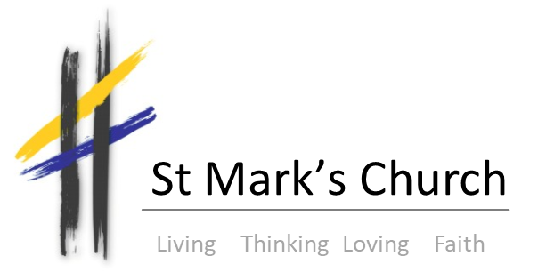

Broomhill and Broomhall, Sheffield

St Mark's Church, Broomfield Road, Broomhill, Sheffield, S10 2SE

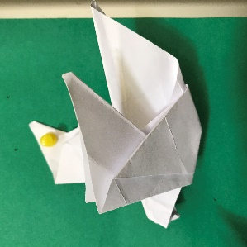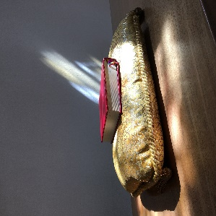

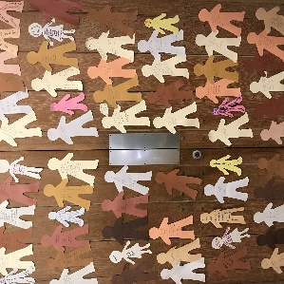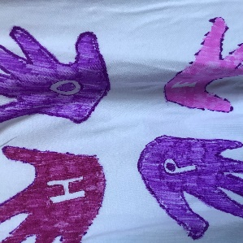

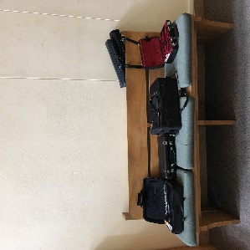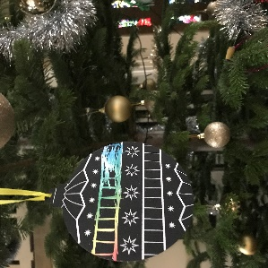

ANNUAL REPORT
for the year to the Annual Parochial Meeting in April 2019

www.stmarkssheffield.co.uk
Our Vision and Mission

St Mark’s Broomhill and Broomhall is part of the Anglican Communion within the world-wide Christian Church.

We understand ourselves to be called to:

- gather together to worship as the body of Christ in this place which welcomes and celebrates human diversity.
- serve our parish and congregation in ways which show the love and compassion of Christ.
- relate our faith to the world around us and campaign for justice both locally and worldwide.
- create a safe and welcoming space where people can question and discover the sacred in their own way.

Living Thinking Loving Faith

We see faith as a journey; dynamic rather than static, with questions as a crucial part of faith and welcoming intellectual challenge as part of our own process of theological discovery.

As followers of a faith inspired by the life and work of Jesus, we work to positively relate our theology and worship to the world we inhabit.

We consider matters of social justice to be central to the gospel and have a strong commitment to inclusivity, valuing difference and offering a safe space for all at every stage of life.

OPENING WORDS
FROM THE VICAR

Once again, the pages which follow are full of wonderful accounts of the life of this vibrant and growing community. Thank you to everyone who has taken the time to write but also to each and every member of this church, for the many ways, visible and invisible, in which you contribute to our worship, our life together and our service of the wider community.

During the year April 2018 to March 2019 we have cried and celebrated, again…

Doreen Godden’s 90th Birthday went largely unnoticed because we were mourning, with her, the loss of dear Roy. As I write, we have just heard news of the untimely death of Kim Willis. In between we said goodbye to Mavis Hewitt and Graham Murray.

Within a community it is the shared losses and joys which bring us together. We have had to work hard to make sense of the idea, “Embodying Hope” the theme chosen for last year and extended into this. Those we have lost have lived faithful, fruitful lives. Whether at work or at home their faith informed their actions and enriched their relationships. We rejoice to have known them and learned from them.

As members of the Body of Christ we have a sense that we are intimately connected, in life, in death, in life beyond death. You could argue that Kim and Roy, and all those whom we love but see no longer, are gone but on Remembrance Sunday last year Roy was as present as if he was standing here in the church. Kim’s vitality and ministry touched so many lives, this cannot be lost. We have much to grieve but so much to be thankful for.

We have welcomed so many newcomers this year that I simply can’t name you all - but welcome!

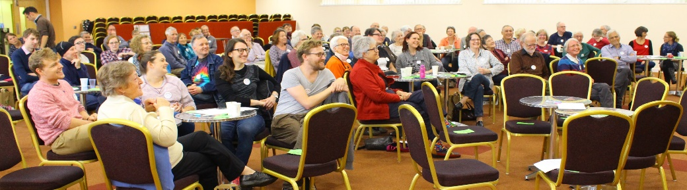
In addition, we have celebrated the baptisms of Ben Speed and Mo Ryder as well as several adult baptisms – Lucy Allison, Katie Hullock, Hannah Speed and Zhara Parhezi who were all also confirmed along with Lu Skerratt, Zhila Zarenya, and Daniel Parhezi.

During this year we witnessed many joyous marriages including, Will & Emma, Trish & Sam,
Oli & Marie, Ben & Becca and Gary & Fiona who then journeyed off to Jordan.

This year we were blessed by the opportunity to share a “BIG WEEKEND AWAY” at Swanwick. The weekend itself was utterly affirming and many of us appreciated getting to know Bishop Pete and Cathy a little better. But perhaps the greatest success of this event was the way everyone pulled together to support the many fundraising events. We had fun and made sure that anyone who wanted to come on the weekend had that opportunity. THANK YOU to everyone who took part!

For this year’s Annual Report we have all been invited to write our particular thank you’s on a special board in church, rather than in our articles but I’m going to cheat, well, I am the Vicar!

This year we said goodbye to our Director of Music, Mark McCombs. Mark established a firm foundation on which to build; we are immensely grateful to him and miss him. We have been blessed to welcome David Willington whose gifts have brought a different perspective to our musical life together. So, thank you to Mark, and to David.

It doesn’t matter how old, or young you are, how little or often you come, how many (or few) jobs you have here – THANK YOU for being part of this extraordinary community of St Mark’s. We really wouldn’t be the same without you! May we all know ourselves to be Wellsprings of Hope in a world which really needs us.

I can’t end without offering my heartfelt thanks to all the clergy and lay ministers who serve this church so faithfully, we are truly blessed.

Sue Hammersley

ASSOCIATE VICAR REPORT

This may be the first Associate Vicar’s report for the APCM but given that the cost of my employment is one of the largest of St Mark’s annual outgoings, it does seem sensible to offer some account of my activities! Not that I can convey much in a few hundred words, of course….

Much of my role simply comprises that of a second full time priest in a busy parish, with a daily/weekly round of services, preaching, preparing liturgies, leading occasional offices and pastoral visiting/ care. This is of course shared between all clergy and wider lay teams as appropriate.

Beyond the shared aspects of the role I have responsibility for various areas of work, both inside church and outside too - the largest of which is to do with children and families. Last autumn I worked with a brilliant team as we outlined and clarified the role for a children and families worker. This took longer than we had anticipated but holding it as a process of discernment ultimately made it clearer to envisage the role. Now Hannah Jones has been appointed, I will be her line manager and a focus group will also support her in her new post.

I’m also a governor at Broomhill Infant School; the commitment to regular meetings, learning walks and spending time in class as well as taking occasional assemblies means that I’m in school most weeks and provide a useful connection. Hosting visits from schools to St Mark’s, or visiting them, is always good fun and provokes really interesting conversations.

As a member of both the study and learning and communications groups I’ve been involved in various projects recently. Music planning and liaising with David Willington also comes under my brief and offers regular opportunities to reflect on worship. I have a wider role as a tutor for the diocesan lay worship leaders’ course and have been involved in the discernment interviews for students as they progress through the stages of lay ministry training. Also at a diocesan level, both Sue and I are now members of Synod. Given the current financial crisis it has been an ‘interesting time’ to join, but it’s helpful to have a better understanding of the way the diocese operates.

I could go on and on listing activities, the doing ; but being the Associate Vicar ultimately comes down to just that – being here. In a year that has seen many challenges in various spheres of life - both personally, locally and nationally, it’s good for me to remember that I have been called to be here, alongside Sue and Shan and the wider staff team, all of whom I count as friends as well as colleagues. This role is both a gift and a privilege.
Sarah Colver

CHURCHWARDENS’ REPORT

Each Anglican parish is required to elect two wardens who are accountable both to the parish and to the bishop. The relationships with the vicar and her associate are central to the role of the wardens, and we are convinced that we can only be effective if there is mutual trust, and our lay leadership is understood as a part of a greater whole. One of the strengths of St Mark’s is precisely the strength of the trust that exists among us.

Perhaps the most important task we have is the work with Sue and Sarah in helping to set the agenda for the church’s mission. We have continued to meet every six weeks or so during this year. These are not decision taking meetings, but they are proving a vital forum for thinking and reflection on the life of St Mark’s; the development of our Mission Partnership; our role within our Deanery; and the impact on St Mark’s and the involvement of St Mark’s in the potential changes and changes taking place in the Diocese as they respond to the financial crisis that the Diocese is facing.

We also find ourselves involved in a very wide range of activities within St Mark’s, either in taking forward initiatives of various kinds or overseeing the work of others. We carry ultimate responsibility for the church building, however we are deeply appreciative that much of the work is being so ably done by others. We have a hand in the day-to-day running of the church and worship.

Pat and Philip do of course divide the responsibilities between themselves. Pat took the lead role in the process of purchasing the flat which we are leasing to Roundabout as part of the legacies project. Philip has led on the purchase of the sketch by John Piper for our west window and has been involved in the meetings of the Mission Partnership.

Dilys Noble, Martin Godley and Rick Hughes do fantastic work as Assistant Wardens each making their own valuable contribution to the life of St Mark’s. Philip Booth & Patricia Hunt
THE PAROCHIAL CHURCH COUNCIL

The PCC welcomed a number of new members this year and has again had a busy year overseeing a wide range of activity within the church. Much of this is carried out by the various groups which report to PCC and will provide their own annual reports. Some of the most significant areas that the PCC has contributed to over the year are:

- The recruitment of a new Director of Music and a new post of Families’ Worker
- The updating of various policies such as Safeguarding, Health and Safety, Social Media as well as the production of a new data policy to ensure the church is line with the new General Data Protection Regulation.
- The completion of the purchase of a house for a young homeless person funded by legacy money.
- The church’s budget and ways to encourage new forms of giving
- The church’s investment policy
- The possibility of hosting the Assist Night Shelter in August 2019
- Mission Action Planning
Juliet Storey
PCC Secretary

PCC GROUPS

CHYPS

2018-19 has seen the continued and exciting development of work with children, young people and students across all age groups as the numbers attending have continued to rise. There’s an increasing breadth to the work which encompasses worship, social events and intergenerational activities too, which are important to build strong links across the whole community.

Following an extensive consultation and discernment process it has been good to finally appoint Hannah Jones as our children and families’ worker. Hannah will take up her post in mid April. She will help us to shape our work with the youngest members of the congregation and support families too. Reports on different aspects of CHYPS work will follow. All of the groups are run by talented and creative teams of volunteers, whose work often goes mostly unseen but is greatly appreciated- thank you.

Sarah Colver

CRECHE

Crèche has continued to work well this year, providing the youngest members of the congregation (mainly under 4s) with an opportunity to get to know each other, and their parents with an opportunity to participate in the service without any distractions.

There are a group of 8 or 9 young children who attend on a fairly regular basis and a team of 6 leaders. A number of parents also regularly stay with their children. Visiting children attend from time to time.
Juliet Storey

GODLY PLAY

Godly Play continues to be the basis of our work with primary school aged children on Sunday mornings. Introducing the youngest to the core stories, whilst continuing to engage older children who are already familiar with the material, is a challenge we need to address. In order to expand the range of stories on offer, Janet Morley has created a set of New Testament miracle stories: the Wedding at Cana, the Feeding of the Five Thousand, Jairus’ Daughter, Jesus Calms the Storm, and the Healing of the Paralysed Man. We are also looking at ways to become more creative with the materials we have, rather than always “sticking to the script”, and we hope to introduce some extension activities with the older children in future. We continue to visit Creche once a term, and the recent music session led by Hannah Jones is something we hope to repeat regularly too.
Sarah Armstrong

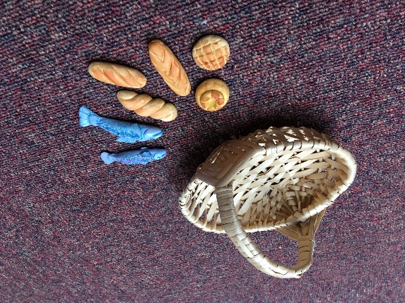
Resources used during Godly Play

8’s TO 13’S GROUP

A small group of leaders continues to provide “a space and a relationship” on Sunday mornings for our older children/young teens. The topics we address are many and varied, ranging from - for example - reading the Bible and meeting Old Testament characters, to discussions about fairness and sharing in the world today. Our work with this age group is constantly evolving and we expect that 2019-20 will see new developments.
Sarah Armstrong

YOUNG ADULTS GROUP

Since the summer of 2018 the Young Adults group has slowly become an established part of the St Mark’s community. The group is made up of 16-25 year olds from different congregations at St Mark’s who meet frequently to share and discuss experiences of being a young adult whilst having a Christian faith. Several of the group were involved in the creation of the March edition of the Mark’s Messenger and many also went on the Young Adults and Friends weekend away in the Peak District at the end of March. The group started as a social space where people could meet others like themselves however it has also become a space to discuss theology and experiences of church. From May 2019, the group will be meeting monthly for ‘Godly Chat’ and will be a trialling a new service on the 2nd June called Big Praise – a combination of inclusive liturgy with contemporary worship music.
Lu Skerratt

COMMUNICATIONS

WEBSITE & SOCIAL MEDIA

It’s been a quieter year for the Comms team. Some tweaks and improvements have been made to the new website and we’re getting into the rhythm of adding seasonal content and photos. Sermons are now added weekly and we welcome news and material from groups to keep the pages current.

The Night Service website will soon start to redirect to the Night Service page on the main site so that everything is under the St Mark’s ‘banner’. We are very grateful to David Anson for setting up and running that site in the past - and especially the mailing facility.

We have decided to discontinue using Twitter as nobody had the capacity to keep the feed live on a daily basis. However, St Mark’s Facebook page continues to have a good following (400+) and an increasing reach - over 2000 people viewed the recent advert for a children’s worker. A small team post material on a regular basis, plus there’s an automatic feed from the church webpage. Two Facebook groups are in operation: St Mark’s Sheffield and St Mark’s Discussion Group. St Mark’s Faith and Justice group also have their own page.

If you can help, please contact the church office.

Sarah Colver

MARKS MESSENGER

The title of Sarah’s Page 2 meditation ‘Always we begin again’ seems to fit the Mark’s Messenger. Every year we find new writers on regular events– not only church festivals, but this year’s Parish Weekend, this year’s Broomhill festival - and they all find new angles. Alongside these steady rhythms we reflect the life of the congregation in both joy and sadness. In this year’s editions you can read about the lives of several much-loved figures no longer with us, alongside photos of cheerful babies welcomed through baptism. Not to mention, of course, the one and only Hawaiian Shirt Wedding of Gary and Fiona. We are enormously grateful that people continue to share their lives through our pages.

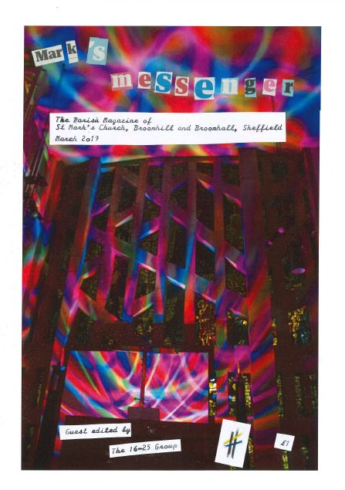
March 2019 edition of Mark’s Messenger edited by the Young Adults Group

We try to reflect the times we live in. The good news can be found in Sarah Eldridge’s New Year article marking the Sanctuary becoming a reality after years of planning. We’ve done our best to challenge some of the bad news, especially by launching a series of articles on Universal Credit. The Messenger’s price increase to £1 per issue is another kind of bad news – but this does reflect the true cost of production, and we like to think it’s worth it.

The editorial team is still only three – we would love it to be larger. We have begun inviting ‘guests’ to edit one-off editions and the 16-25 group did a brilliant job in March. Do follow their example – we will help you all the way!
Frances Gray

FABRIC & FINANCE

The Group meets four times a year, with a very full agenda of items large and small. A change of treasurer has made it interesting to get to grips with David Armstrong's mindset, coming as he does from a different professional background from David Ryder. The two of them still work closely together to the benefit of everyone.

This building is now showing signs of age, and we try to keep it attractive and safe in a way which is both practical and economic. In the past year we have completed the installation of a bench near the Memorial Garden, the redecoration of the Upper Room and the provision of safety barriers to use when the lift is serviced.

Ongoing work includes the preparation of a controller for the church heating system to make it more responsive to our needs; this should be in place for next winter. We are currently looking at the possibilities for replacement audio-visual systems in the church, and once these have been decided upon some of the existing components will be used to improve facilities in the Lounge and the Upper Room.

Future improvements should include the provision of new bicycle stands, restoration work to the tower and spire and possible protection for the stained glass in the East window and secondary double glazing. We hope to refurbish the Lounge this summer.

Robin Saunders stood down as Fire Officer after many years’ service and Martin Godley has taken on this role. He will be organising fire safety training very shortly.

We have recently made two other appointments – David Stanton has taken on garden maintenance and already the North border is looking much tidier. We also have a new consulting architect to provide us with more active support in caring for the church and for planning ahead. We look forward to working with him on your behalf.
Briony Tayler

CARETAKING & CLEANING

Summer last year saw the metal hoops on the green pulled up, and a bench by the memorial garden put in; the stripping and repainting of the railings advanced a few more meters, and a handrail was installed in one of the ladies toilet cubicles.

In the autumn the walls in the upstairs kitchen were patched up and repainted, and the worktops replaced, all as part of the wider refurbishments upstairs.

At Christmas, part of the altar carpet got new underlay and adhesive. The water boilers have been replaced and repaired several times, for a variety of reasons, and all the fluorescent lights are gradually moving over to digital starters. This year already, the drains under the north path have been replaced and lined, due to root ingress; the guttering downpipe by the choir corner has been fitted with mesh to prevent blockages from leaves, and the bell rope has been replaced.

The ongoing project to replace the AV systems in the building will hopefully see some results this coming summer, coming with the refurbishment of the downstairs lounge. And, of course, the railings still need stripping and painting.

For the cleaners it is mostly business as usual, except they have gained a new brown recycling bin, and all their cleaning products are now eco-friendly. In the upstairs kitchen there are now separate bins for recyclable materials.

Tim Moore & John Whitmill

LEGACIES

The legacies group was set up in 2016 to consider how the legacy from Alan Birchall should be used. The group set broad criteria for the way in which the money should be spent and identified projects which would advance St Mark’s mission. Since then, we have received further generous legacies and the group has continued to meet in order to recommend ways in which all the legacy monies should be spent and to oversee the work of the groups set up to carry projects forward. During the past year, four projects have reached fruition:

- The purchase of a flat to be leased to the charity Roundabout for housing vulnerable young adults. After considerable research, a suitable flat was found and completion of the sale took place at the end of the year.

- The appointment of a children and families worker. The original proposal was a for worker with the 16-25 age group, but after extensive consultation, it was agreed that the more pressing need was with families of younger children.

- he contribution to the purchase by Museums Sheffield of John Piper’s sketch for the west window.

- The making of a missal stand for the altar in memory of Isobel Bowler.
Three further projects are ongoing:

- Purchase new audio-visual systems for the church, the lounge and the upper room;

- Refurbishment of the kitchen.

- Setting up a trust fund to make grants to both clergy and laity at St Mark’s and the creation of a children’s library in memory of Eileen Stamper.
Philip Booth & Patricia Hunt

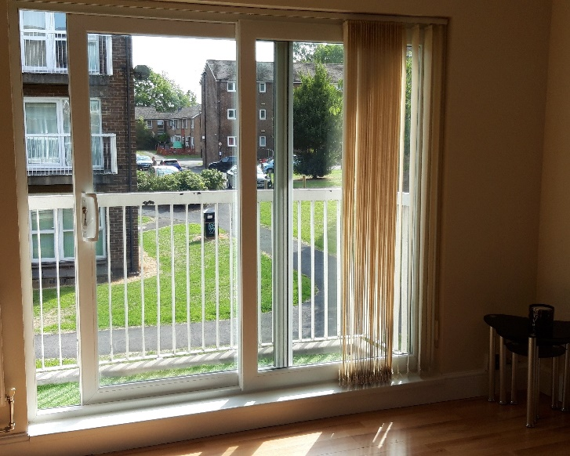

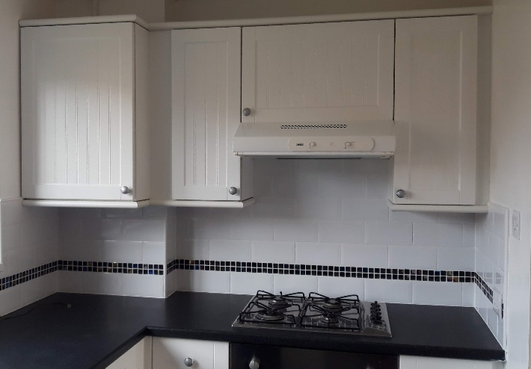

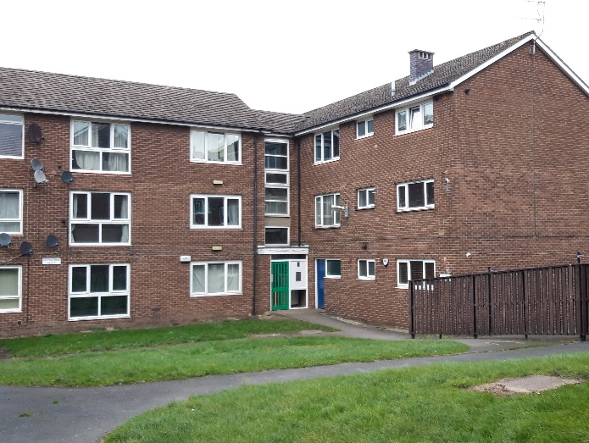
The Roundabout Flat

FAITH & JUSTICE

St Mark’s Faith and Justice Group brings together members of St Mark’s congregation and partner churches who see their Christian commitment as embracing social action in the parish of Broomhill and Broomhall and more widely. It believes in equality and diversity and wants Sheffield and the church to be places of justice, fairness and compassion.

In 2018 the Group carried out a review of its aims and activities in order to make its work more focused. It has agreed that its aim is: ‘to work for social justice, inspired by the resources of the Christian community’. Its objectives are:

- To ensure that St Mark’s is involved in and committed to faith and justice matters;
- To have an active influence on faith and justice in Sheffield and beyond, and in wider society and within the church;
- To develop understanding of faith and justice questions.

It has decided to pursue the following themes during 2019:
- Challenging the Church of England on gender and sexual equality (this work will be carried out jointly with St Mark’s Study and Learning Group);
- Climate change;
- Poverty and inequality.

We seek to achieve these aims and objectives by:
(1) planning campaigns and other actions; (2) communicating with the congregation and others; (3) collaborating with other churches and organisations; and (4) by reflection and learning on the links between faith and justice and their theological underpinning.

Joe Forde

HOME DONATIONS

Home Donations is the group which has the happy job of giving grants to voluntary and community organisations to promote social justice and wellbeing. The donations come from congregational giving. The Group looks at needs in the city, new concerns and fresh ideas. When poverty is growing, and Sheffield is suffering the consequences of austerity Home Donations couldn’t be more important.

We communicated with the congregation by articles in the Messenger and presentations from grantee organisations about their work and the impact of our grant.

Our decisions were made on the basis of our aims:
- help organisations tackle need;
- impact on the causes of social injustice;
- help organisations make an identified difference to promoting social justice
- support some continuity (of funding) where possible.
The major grants were made to:
- Broomhall Youth Club for a youth worker for a term and the premises.
The club does important work in a part of the parish which is most deprived.
- a project to buy lap tops for community based organisations which give advice and support claimants. This is a vital project because the new benefits system, Universal Credit, is being rolled out in Sheffield and it requires claimants to apply online.
- ASSIST, the refugee and asylum seeker group, this time funds were given to pay for the running costs of a house for a year.

“We greatly appreciate
the support of the congregation
who do so much
for the most marginalised
in our society”.

- City Of Sanctuary to continue to develop their building as a drop in and training centre.
- Hope for the Future to train 10 Sheffield based students to learn how to lobby about climate change.

Home Donations made four smaller grants: to The Suit Works which provides suits for people going to an interview after a time unemployed along with some mentoring; the Sheffield Association for the Voluntary Teaching of English (SAVTE) working with asylum seekers and others to learn English; to the Jesus Centre food bank to support their work and lastly, we donated to the Children’s Society.

Judy Robinson

INTERNATIONAL DONATIONS

Christian Aid has remained the major recipient of St Mark’s overseas donations (15% 0f the available £13,143.00.) Christian Aid week 2018 House to House collection raised £1,562.02. a truly great result. The total raised from Sheffield £42,231.00 so although it seems a chore it is worth it!

A few members of St Mark’s hiked on May Day, hosted a Big Brekkie “Afternoon Tea” and sang Carols in Far gate to increase our contribution to the total of £53,100.56 Sheffield sent to Christian Aid in 2018.

USPG received 10% of the total.

The following Charities all received 8.3% of the total.

NEW Traidcraft ceased trading at the end of 2018. Many of the congregation are passionate about Fairtrade so supporting Traidcraft Exchange, the political and lobbying arm of Traidcraft, that was previously funded by the profits from Traidcraft sales seemed an obvious choice.

NEW The Syrian refugee problem is a priority for many, so a project through UNHRC to enable young Syrian Refugee in Lebanon to return to school was agreed as cause that the congregation would support.

We continue our support for South Yorkshire Development Education Centre and Global Justice Now (both national and local groups) as we feel education about world matters is of vital importance.

We have continued to support Succol; Literacy for Life ; Tek Ura and the Omid foundation. Dez and Jeannie Martin Visited SUCCOL in Colombia in the summer and gave an engaging talk about their work in supporting further education there.

Rosie Hunt showed a short video and update about Literacy for Life in Ghana after the 1st Lent lunch this year demonstrating sustainability and progress.

Ceri Gallivan showed a brief video about the hospital at Bwindi in Uganda at the same lunch although we decided not to fund this project directly this year but hope to again in the future.

Phaseworldwide benefitted from another concert held in the church in November again it was decided not to fund this directly from the church funds

Amnesty International was supported by events including the 70th anniversary of the UN Universal Declaration of Human Rights and selling Christmas Cards.
Dilys Noble

ENVIRONMENTAL CONCERNS

The last year has seen encouraging new initiatives at St Mark’s; following an exploratory meeting in March 2018, a small group has met regularly to plan practical actions. A workshop at the parish weekend in September introduced the framework of Active Hope (expounded in a book by Joanna Macey and Chris Johnstone). This has led to two further workshops in October 2018 and March 2019 which have involved a wide range of members of the St Mark’s community, exploring the questions, what are we already doing, what do we want to do next, and how can we best support one another?

Recent public debate, for example about urban air quality and the need for a more plant-based diet has been encouraging and resonated with local enthusiasms. Younger adults in the community featured environmental issues prominently when they had guest editorship of the Messenger earlier this year, there was a display of relevant books at the 10 o’clock service on 17th March, an environment themed Night Service on 24/3/19 was well received and will be repeated during Holy Week and there will be a Healthy Planet/Flexitarian lunch on 7/04/19. These all signify a broadening of the group in St Mark’s which is actively participating in our response to climate change and in the range of those responses.

Meanwhile a number of longstanding projects are moving forward; we have enrolled in the Eco-Church scheme, Hope For The Future has a new chair of the board of trustees in Glynn Turton and members of the team gave an energising presentation after the 10 o’clock service in Summer 2018.

Rachael Hand & Rick Hughes

SOUP RUN

Our Soup Run continues its provision to the city’s homeless and/or vulnerably housed population every Sat evening of the year (apart from Christmas week when HARC runs) from Angel St in the city centre. We bring hot drinks, soup and sandwiches which we make from bread donated by Roses bakery in Ecclesall. We also give out other savoury and sweet finger foods donated by both Roses and Greggs. We have a small stock of sleeping bags and clothing which we give out if needed.

We have around 60 volunteers currently – split into 5 teams who do it regularly and a list of reserves. The team supervisors work hard, coordinating the food donations and taking responsibility for the various tasks on the evening. We meet regularly to discuss our provision and whether/how it can meet the complex problem of food poverty within our city. I am going to stop doing the admin/co-ordinating role soon due to work/family commitments and am grateful to the people who will be taking on these roles instead of me.

We welcome donations of sleeping bags (but not pillows or duvets), hats, gloves, socks, jumpers and warm/waterproof coats. Thank you!
Jen Ryder

PASTORAL CARE & HOSPITALITY

Embodying hope - during the year we have realised afresh what we already knew in practice that there is a wonderful continuity of love and care in all our activities and not least in the area of pastoral care, hospitality and welcoming . Please see Briony’s report “Sunday lunches – part of our hospitality, welcome and outreach”. Rosalind Rogerson’s report on the “Lunch Club” and that of Claire Brooks, CTTB Worker with Older People , confirm that oneness that we seek to offer.

The core group has continued to meet regularly to consider various matters eg “The keeping in touch” telephone network, the ministry of cards, the bereavement visitors scheme and the inter play with the work of the Welcome teams.

We are aware that we are a growing church numerically and need to review regularly what we offer in terms of pastoral care and friendship and how we are as learners in giving and taking help. Ideas and comments are always welcome.
Gill MacGregor
SUNDAY LUNCH

These are now an embedded feature of life in St Mark's, as for many they continue the welcome offered immediately after the service, and provide a friendly place in which to talk and get to know one another leisure. Lunch is also a good opportunity for those who attend to learn more about some of the charities we support, from those who are most closely involved; the recent series of Lent lunches has benefited from lively presentations concerning projects overseas and close to home. The average attendance has risen over the past year to around 30, but it can vary from 12 to 40+ – a challenge to the cooks! The basic charge is still £3, with profits absorbed into the Hospitality Fund when not collected for the benefit of good causes. The Hospitality Fund enables special celebrations to be catered for without charge.
Briony Tayler

LUNCH & FRIENDSHIP CLUB

In this time of change and “rebranding", it is amazing to see that the Lunch and Friendship Club continues operate almost exactly as it was originally conceived to do nearly 30 years ago.

Barry arrives first, to put out and lay tables for 30 to 40 people, an essential task he performs week in week out. He is soon joined by one of the four cooks, then by the helpers in due order, to ensure that a nourishing hot two-course meal is ready for 12 o'clock. Sherry is offered each month to celebrate birthdays, and occasional gifts of sweets are a jolly addition to tea and coffee after lunch. We generally serve meals which are traditional in style, using the best fresh and frozen ingredients and taking account of our members’ small appetites and preference for food which is easy to eat.

After lunch the buzz of conversation continues. About three times a term we have a service in the chapel. At 1:30 PM Friendship Club begins. The club's activities are advertised weekly in the blue sheet, inviting anyone to join in with this mixed and carefully-planned programme. The wholehearted response of members to these activities ranges from energetic (music from yesteryear) and fun (watching someone's holiday pictures) to tranquil (concentration, as we prepare the next collage) and purposeful (a quiz).
Our merry band of volunteer helpers gets recognition elsewhere, but mention must be made here of Transport 17, whose care for passengers is exemplary. We acknowledge a generous grant from Sheffield City Council. We remember with love and much respect those members who have died during the year: Mavis Hewitt, Freda Whalley and Jean McLean, also Roy Godden, who audited our club accounts with diligence and good humour from 1991 to 2018.
Briony Tayler and Rosalind Rogerson

KNITTING & CRAFT GROUP

The group continues to meet each month with varying numbers of people.

Our main knitting project for the year was a set of nativity figures to be circulated round and welcomed into people’s homes during Advent. As well as Mary and Joseph, we made baby Jesus (with a crib), shepherds, sheep and kings. Our knitting pattern showed Jesus in Mary’s arms, so it was fortunate that Sarah pointed out that, for the posada, we needed to have Mary alone and Jesus in the crib waiting for Christmas Day!

We have now started knitting some 3 inch and 6 inch squares using our own wool and wool which has very kindly been donated to the group. We have several uses for these – baby blankets, fiddle mats which can be decorated with buttons, ribbons etc (for Sheffield Hospitals Charity for patients with dementia) and bigger blankets which are sold to raise funds by Oxfam.

Nicole came back for a few months during the year and several of us met up and enjoyed a meal at the Thyme Café in February to wish her good luck on her return to Canada.

We meet on the first Saturday each month from 10.30 to 12 in the church lounge and would love to see more people coming along to share our fellowship.
Jennie Martin

STUDY & LEARNING GROUP

The Group’s major undertaking in the last year was to devise a questionnaire around the eight principles for study and learning at St Mark’s which the PCC adopted last year. The questionnaire was circulated in January, to

- check out wider congregational perceptions
- find out what study and learning opportunities people had undertaken
- discover what they would like to see St Mark’s providing
- ask what particular gifts and skills people might be able to offer.

67 people responded to the questionnaire. A summary of responses was circulated at a feedback meeting on February 10th and made available at the back of church. There was a high degree of consensus that the principles provided the right framework for developing all future opportunities. We also gathered together ideas about areas where people would like to see future provision being made. These broke down into seven groups:

- equipping for daily life and action
- engaging with societal issues
- Biblical study
- theology and ecclesiology
- the world of the arts
- interfaith
- prayer and spirituality.

It’s not the group’s role to write courses but to encourage others within the church to do so. We will attend to this in the coming months.

At the same time, some members of the group together with members of Faith and Justice have started to explore how St Mark’s can respond to two major issues of justice and equality which the church faces: women, ministry and the church; gender and sexuality.
John Schofield

LENT COURSE

It is a little difficult to report fully on this year’s Lent activities as the late date of Easter means that the groups are still meeting at the time this report is being written.

We have, in line with the overall theme for St Mark’s this year, continued exploring the theme of Hope. However, we decided that it was important to bring some positivity to the discussion, so we adopted Wellsprings of Hope as our theme. The five sessions move from Starting with Gratitude, through Seeing Afresh to Challenging Poverty and Honouring our World to Reclaiming Hope. The sessions contain the usual mix of theological, biblical and personal input, and most start with reflection on a work of art.

Alongside this, special readings and collects were chosen for the 10am Eucharist, and the accompanying sermon series.

A disappointment this year was the comparatively low take up. I would like to thank all those who helped me shape the material, those who volunteered to host and/or facilitate the sessions, and all who have taken part. I hope some of the outcomes of the groups’ work may be shared with the congregation through changes to the board containing information about the group.

John Schofield

WORSHIP & LITURGY

THEMED SERVICES

We’ve continued during the year to hold occasional 10am themed Eucharists when, still holing to the shape of the Eucharist, we approach a subject differently and hopefully in a more multisensory way. We’ve spent time watching video clips, writing and reflecting, signing and singing. We’ve discovered that, given the right context, St Mark’s congregation can be willing to lift their hands up when they worship!
In May we thought about Homes of Hope, picking up on a theme from Christian Aid week, and in September we offered time to reflect on New Beginnings. At Candlemas people brought lots of candles into church, both old and new - young and old, all together.

ALL AGE INTERACTIVE

We are so fortunate to have such talented people in this congregation: Jen Ryder has prepared several 4pm all age interactive services during the year. These are times set apart for creative, multi-sensory prayer, reflection and worship – a real gift! If you have never been, please do try to come to the next one on 19th May. The aim has been to hold a monthly afternoon gathering for families, so these have been alternating with social events.

OPEN SHEFFIELD: OPEN COMMUNION

On the 2nd Sunday of every month St Mark’s hosts Open Sheffield: Open Communion which has now been running for about a year. This ecumenical service offers a safe space for those who identify as LGBTQIA+ and their allies to gather and to share in Eucharist. Some may wonder why this is needed, given that St Mark’s is such an affirming congregation, but for those who are cautious of engaging with Christian faith at all, or who have been damaged by previous experiences, it provides a welcome sacred space. A regular congregation of around 20-25 come from across Sheffield and further afield; the clergy leading the service also come from a range of churches as well as the ‘home team’ all playing an active part.
Sarah Colver

NIGHT SERVICE

This has been a mixed year for Night Service, with the congregation varying notably in its number and makeup from week to week, and other overlapping groups (such as Gospel Choir, Young Adults, Open Communion) providing some of the community aspects once sought at the 8pm.

As in previous years, attendees are a diverse mix, consisting of regular members of St Mark’s who only come to Night Service, members of St Mark’s who attend other services too, and members of other churches who additionally come to Night Service.

We continue to rota the services by the Sunday of the month. Taizé is by far the most well-attended with up to 50 people expected each month, many of whom are not otherwise involved at St Mark’s.

There has been a variety of thoughtfully prepared liturgies and experiment styles of worship devised by lay curators, and some effective collaborations with the Gospel Choir as well as other musicians and small ensembles.

Conversations about the opportunities that Night Service provides will be occurring in the near future, and we look forward to the arrival of Caitlin, the incoming curate, whom we hope will offer some fresh insight and leadership for developing this valuable space in the years to come.
Ben Ryan

JULIAN PRAYER GROUP

Julian prayer takes the form of contemplative prayer in the Christian tradition. It takes minimal organisation as we take it in turns to introduce the prayer time by choosing a few simple words to share. These words are sent to the group by e-mail, which means everyone can engage with the reflection, wherever they are. This unites this small group of people seeking space for silent prayer whether that be in their own home, travelling or gathered in the chapel on a Monday night at 6.30 pm. After the reading, we hold thirty minutes of silent meditation, followed by an invitation to pray out loud for people or situations. We end by sharing in the words of The Grace. One person’s experience of the group is that “ the gentle, considerate and prayerful response of individuals helped sustain me.” Come along or ask to be included on our mailing list.
Shan Rush

FLOWER ARRANGERS

We are a team of seven regular flower arrangers we arrange the flowers in church every week apart from during Lent and advent.

The flowers are financed by a different member of the congregation every week in memory of a loved one or for an anniversary or just because they want to contribute towards the flowers We fully decorate the church for special celebrations Christmas Easter and harvest on these occasions a few extra people come and help us. I liaise with all wedding couples to see what their flower needs are for their special day.

If you like arranging flowers, please come and have a chat to me we would welcome extra pairs of hands.

Mary-Jane Ryder
MUSIC

I’ve been at St Mark’s for about 6 months and have enjoyed every minute of it. I’ve inherited a musical tradition from my predecessor Mark McCombs that has given me a wonderful platform to build on.

I’ve been asked to encourage more people take part in music making at the church and folks have seemed very keen. Several new singers have joined the choir for Sunday mornings and weekly rehearsals, and the choir have been supported by visiting organists as well as instrumentalists from the congregation and beyond.

I’m still finding my way through the church year at St Mark’s and I’ve had huge support from everyone in doing this; I’d like to express my thanks to everyone who’s helped in whatever way (accompanying choir rehearsals, sorting out the music library, arranging social events, organising trips, reminding me when I’ve forgotten something critically important etc etc). It’s a tribute to the commitment and enthusiasm of all concerned that we are able to add such a varied musical element to so many services and we plan to continue experimenting with repertoire, instruments, musicians and other elements both in the church and further afield.

As part of engaging with people beyond the St Mark’s community we’ve contacted organists and music leaders in several churches in our area, including in our Mission Partnership. We’ve also spoken to schools in our parish and have plans to work with them and their students to enhance our music, and give their students new opportunities. We welcomed a number of young musicians from the Sheffield Music Hub who have contributed to 2 of our services and gained musical experience for themselves, and we plan to do more of this collaborative work in the future.

Night service and the Gospel Choir continue to develop and attract singers and musicians. The rota at night service continues and I plan to become more involved in supporting those services musically.

The organ is half way through its 10 year warranty from the recent refurbishment. Paul Hale (consultant) visited to assess the current state and gave it a clean bill of health. I consider myself extremely fortunate to have the opportunity to play one of Sheffield’s best organs every week.
David Willington
GOSPEL CHOIR

Gospel Choir is over 2 years old now and steadily growing. We have around 30 regular members but more like 15-20 at your average rehearsal. We have enjoyed performing at a wedding and a Christening, and more recently at St Marks' pancake day feast. We still sing at night services every few months and the choir leader, Sarah Robinson, led two workshops at the St Marks weekend away in September 2018 (which led to a few more recruits to the choir!). The choir has a real sense of community, with some members saying they love to come in the middle of a busy week to unwind and sing. We are looking forward to a possible choir mini-tour to Birmingham this year with the chance to build greater friendships and perform our first concert.
Sarah Robinson

CHURCH OFFICE

Having been at St Mark’s for over a year now, it’s good to have done a full calendar year of the festivals, services and events – at least now I know what to expect for each coming month, and can plan accordingly.

I’ve continued to build my role, getting involved in the St Mark’s Community more, and I do very much feel like a member of St Mark’s, even if a little removed as I don’t attend services.

This year I’ve welcomed a new (cheaper!) photocopier into my office – so far we have a good relationship!

In the last year I have been involved in the organisation, and attended both PRIDE, and the Broomhall Festival at St Mark’s – I look forward to both again this coming year.

I have also introduced an online system for streamlining the process of putting together the Sunday 10 am rota – which has made this task so much simpler to manage!

I have also undertaken an audit of church key-holders, completed the mammoth task of updating the Congregational List and produced a leaflet advertising the church rooms for hire. I continue to increase room bookings (please contact me if you’d like to hire!), and to manage the church website, and look forward to some formal training in website management in the next months.
Sarah Rousseau
LIBRARY

The library continues to be a valuable resource to both our congregation and to CRC members. Books are donated or bought at the request of our clergy and our readers.
We have a wide range of readers, including students who are preparing for Lay Readership or the Priesthood, Night Service attendees and our morning Sunday service participants, as well as members of CRC.
In February this year, I set out a selection of ‘suggested reading’ library books on a table at the back of church after the Sunday morning 10.00am service and this was very successful.

In April the display has been organised in conjunction with the Environmental Group. A selection of books from the library will be available to borrow, and there is a selection of suggested reading provided by Michael Bayley.

The catalogues and list of New Books, are published on the church website, the CRC website and the PCN website and regularly updated. Nearly every book purchased is from the part of Amazon which is dedicated to second hand book dealers, and I find this very economical and easy to use.

I am very grateful for the help of a team of 12 dedicated helpers on the rota. They each have one library duty every three months, which is not too onerous. They give time and thought to assisting in the smooth running of the library and they represent a wide range of views and interests.

Maureen Bownas

MISSION PARTNERSHIPS

Our partnership with St John’s, St Mary’s, St Tim’s and The Vine is growing – at least between the clergy and lay representatives. The new Vicar of St Timothy Crookes, Malcolm Lambert, has time allocated to serving this team of churches and we now have an official steering group which is meeting regularly.

Last year we reported that there were three vacancies. All of these have now been filled, but St Tim’s and The Vine with fixed term interim ministers for 3 years. The new Vicar of St John’s, Matthew Rhodes, is also the Area Dean.
What has been encouraging is that over the past year a degree of trust has developed between all those involved in the steering group and there has been an exploration of ways in which activities and resources might be shared between the parishes. But the group has had to live with considerable uncertainty within the diocese and our Hallam Deanery. Everything could change with the new diocesan strategy and the deployment of far fewer clergy across much larger geographical areas, so our relationships with neighbouring churches are increasingly important.

If you live in one of these parishes, perhaps you might like to act as a link between our churches, visit them from time to time and see what they do.

There is so much potential for how this network could develop, but our next step is to help the congregations to start making connections. Any ideas?

Anne Padget, Jacque Ryan, Philip Booth & Sue Hammersley

CTBB

One of the things I liked most when I first ventured into St Mark’s Church was the fact that the Beacon, St. Andrew’s URC Church and St. Mark’s were committed to working with one another and addressing some of the major issues facing the “church” in the city of Sheffield and more specifically Broomhill and Broomhall. Unfortunately, circumstances are such that when the present minister, Will Fletcher, leaves the area this summer it is almost certain that the Beacon Church in its present form will cease to meet. Although it is uncertain what the building will be used for in the future, the Sheffield Circuit has committed to support CTBB and continue to provide a space for the Worker with Older People. This is a great relief.
Claire Brookes report may be read below.

CTBB serves an excellent parent body for the Broomhall Breakfast and the Broomhall Youth Groups – you can read more about this in their reports.

The Broomhall Breakfast draws in people from all over the city and numbers 40 - 70 people each week.
It’s a very friendly atmosphere where representatives from all three churches take on various roles in order to support many people who might otherwise be lonely, and in some cases unable to afford what is undoubtedly a superb breakfast. The Breakfast received a visit from the mayor in February where he was well received.

CTBB acknowledges all the work that Kim Willis put in to the work of Churches Together over the years and as Moderator for the last two years. It is with deep sadness that we mourn her recent death following a short illness. We extend our heartfelt feelings of love to the family at this time and hope they will gain strength from the knowledge that we are thinking of them at this difficult time.

Rob Wilks

BROOMHALL GIRLS’ GROUP

The club has had some significant but positive changes throughout this year. Youth worker Hannah Cawley stepped down from her post, having built a healthy cohort of ten girls who regularly attend Wednesday evenings taking part in a range of activities including cooking, arts and crafts and sports. Since then, we are delighted that she has remained part of the committee, while Vicki Sampson (a previous volunteer) has delivered a smooth transition enabling the girls to feel supported and engaged. As well as weekly meetings the girls have enjoyed various outings, including visits to the theatre and a film night celebrating International Womens’ Day, rock-climbing and ice-skating as well as meeting the Lord Mayor, Majid Majid.

Meanwhile, the committee have made great inroads into building relationships within the community, attending the Group of Groups and supporting the development of the Broomhall Youth Forum, as well as building an active partnership with Unity Gym to deliver the boys’ club on Friday evenings. This partnership has enabled us to be involved with a new initiative from Sheffield Futures to run a second girls’ club for the next year which will be specifically for 10-13 year-old girls. We are delighted to have appointed local youth worker, Sahra Ahmed to lead this group.

We are busy seeking fundraising as our increased activity has raised our annual budget and we are also reviewing the way in which the club is organised. For the time being, we continue to run under the umbrella of Churches together in Broomhill and Broomhall and are grateful for their support.

Hannah Jones

WORK WITH OLDER PEOPLE

I have been with CTBB for almost 3 years and continue to find the work challenging and demanding, but interesting and varied.

The one to one visits to older isolated people living in the community continue to take up the majority of my time, which can include the support of their family and carers, or indeed involve being the only person to assist and advise with daily issues.

With an ageing population in Sheffield and more people staying longer in their own homes and receiving support services, an important part of my role has been to assist to set up care packages and recommend reliable agencies. I have set up a list of more local recommended providers and can give advice on charges and help with contact and introductory visits.

Home visits play an important part of my role and take up the majority of my working week.

I continue to visit Broomgrove Nursing Home once or twice a week and provide individual time to 5 residents at present. I feel this role is important as it provides a visit from outside the staff and allows me to act as a befriender and advocate.

I continue to be a member of the Pastoral Care Group at St. Marks church, where I regularly attend meetings and keep informed about those members of the congregation that might need advice and one to one support from me.

I now have 2 volunteers working with me who each provide a fortnightly visit to a person I have supported for a long time.

I continue to reach as many people as possible within the communities I serve, but still feel the limitations of the actual numbers I can support as a lone worker.. My focus is to provide a high standard of care and support to those I visit and to be able to act in a timely and effective way when new referrals are made.

The full report on which this is based will be available at the AGM of Churches Together in Broomhill and Broomhall, or by emailing ctbb546@gmail.com

Claire Brooks

BROOMHILL FESTIVAL

This was the second year that the Festival had been run by the current committee. Once again, the Festival was kept to just 8 days and the organisers of each event raised funds for a charity of their choice, giving 10% of any profit to the Festival to cover the costs of the brochure and web site. The Festival has a new web site: www.broomhill-festival.org.uk.

There was a good mixture of events, as in the previous year. Evening concerts were given by the Bach Choir and the Sheffield Philharmonic Orchestra and there were two daytime concerts. The schools’ concert was reinstated. The Library ran events almost every day, most of them for children and linked to health and wellbeing because the year was the 70th anniversary of the NHS. MarksThree gave a words and music concert, there was a slide show and talk about WWI ambulances, and a talk and quiz about Sheffield cutlery. Broomspring Writers’ Group ran an open session and there was a Contra Dance taster session at Birkdale School, a posh-car-boot sale at Westbourne School and early morning Tai Chi sessions on St Mark’s Green. The local history walks run by the Library featured Sale Hill. A number of gardens were opened including the Library, Pisgah House, the Endcliffe Triangle gardens and gardens on Westbourne and Southbourne Roads.

A very unusual event was the Woofyt Day at St Mark’s. The Woofyt is a Wooden One-octave Organ for Young Technologists (type Woofyt Organ into Google). There were many entries for the art-on-a-postcard competition. St Mark’s held a Great Get Together and the highly successful Festival was rounded off by the Festival Service and a Bring-and-Sing Faure Requiem.

A more in depth report of the work of the Broomhall Festival can be found on their website – www.broomhill-festival.org.uk

The Broomhall Festival Committee

CRC

CRC is now 16 years old with a rich and varied history. In the past year we made a link with this when Marianne Borg came to deliver her conference “Days of Awe and Wonder: How we see makes all the difference” on 20th October. It was lovely to reflect on the connection that we had always had through her husband Marcus, who was key to the formation of CRC, as well as embracing her as an excellent theologian and minister in her own right.
Sue Hobley stepped down as the Chair of CRC on 31st March this year and we thank her for the time and effort she put into CRC, both as Chair and on the council. As someone who was not based in Sheffield we particularly appreciate what went into her dedication to the organisation.
At CRC are currently looking at how we can enhance our offering to the Christian community and beyond.
Due to the legacy left to us by Jim Cotter we are progressing with the online presence for inclusive and liberal resources that will be made available. The official launch for this will take place next year, but it will be up and running before this. Watch this space!
At CRC we feel very strongly that there is an appetite for the liberal and radical Christianity we offer up to people. A safe, inclusive space is needed for people and an opportunity for stimulating and creative exploration. The physical space of St. Mark’s is an important feature of this. As a building at the centre this is one thing that makes us different from progressive organisations like PCN who operate as a network.

St. Mark’s is a church that has many resources and offers worship that is open and inclusive. We are very lucky to be able to worship here. Other people are not so lucky to have this kind of resource. As CRC we want to be able to reach out to others so that they may realise they are not alone in their theology, their lifestyle or their approach to life.
One way in which we are doing this is to develop the process we have regarding who we invite for conferences. If we are to reach out to others, we need to have people speaking who have also felt that isolation from the Church and been marginalised themselves.
We have many things in the pipeline going forward that demonstrate both our rich history and the ways in which we are moving forward. Richard Tetlow will be with us on 3rd of July talking about his book “Perceptions of Christianity”. And on October 19th we are delighted to be welcoming Padraig O Tuama, who will be delivering a conference on “Borders and Belonging”. Information regarding these is on the CRC stand and on our website at www.stmarkscrc.co.uk.
Next year our focus will very much be on those have felt marginalised, reaching out to others who feel the same. As I said above, at St. Mark’s we are privileged to have the safe space that we do and understandably, not everyone will then feel motivated to support CRC directly or come to the conferences. However, with our faith also comes those moments when we have the opportunity to present others with the chance to be embraced in areas of their life when they have previously felt rejected. So, maybe we can all keep an eye open for this and help increase the awareness of CRC when those moments present themselves.

Anne Padget

John Piper’s sketch for the west window

